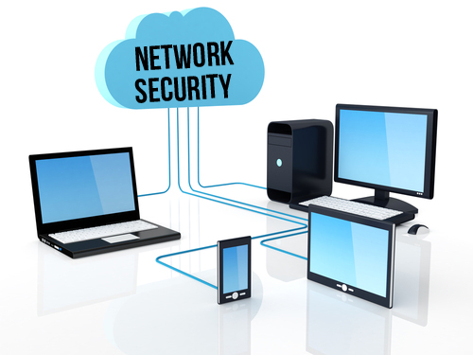

A REPORT ON
IEEE SUMMER PROJECT
NETWORK SECURITY
BY AMAL BYJU
ROLL NUMBER : 16CO205

What I have learnt

A brief description of what I have learnt is as follows :

1. IP addresses and DNS servers

I learnt various network topologies, how IP addresses are assigned to different computers along with address mapping protocols such as ARP, DHCP, BOOTP etc. ARP (Address resolution protocol) is used for mapping a network address (e.g. an IPv4 address) to a physical address like an Ethernet address (also named a MAC address). The Address Resolution Protocol is a request and response protocol whose messages are encapsulated by a link layer protocol. It is communicated within the boundaries of a single network, never routed across internetwork nodes. This property places ARP into the Link Layer of the Internet Protocol Suite, while in the Open Systems Interconnection (OSI) model, it is often described as residing in Layer 3, being encapsulated by Layer 2 protocols. However, ARP was not developed in the OSI networking framework. The Reverse Address Resolution Protocol (Reverse ARP or RARP), like In ARP, translates Layer 2 addresses to Layer 3 addresses. However, in InARP the requesting station queries the Layer 3 address of another node, whereas RARP is used to obtain the Layer 3 address of the requesting station itself for address configuration purposes. RARP is obsolete; it was replaced by BOOTP, which was later superseded by the Dynamic Host Configuration Protocol (DHCP).
The Dynamic Host Configuration Protocol (DHCP) is a standardized network protocol used on Internet Protocol (IP) networks. The DHCP is controlled by a DHCP server that dynamically distributes network configuration parameters, such as IP addresses, for interfaces and services. A router or a residential gateway can be enabled to act as a DHCP server. We further researched about DNS servers and how they work.

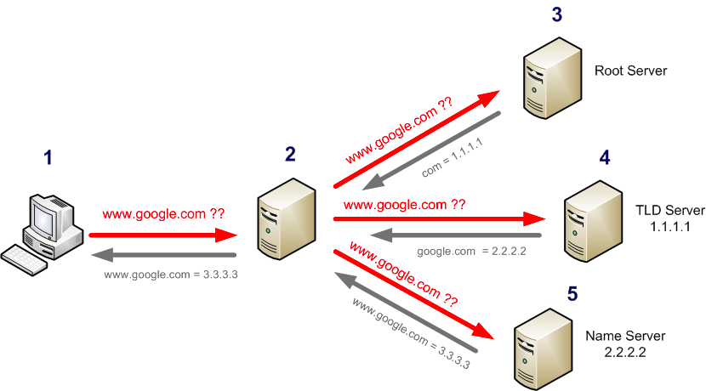

2. Subnets, subnet masks and NAT

Subnetting is basically dividing a big network into smaller networks.
Subnetting a network divides the host address part of the network into Subnet ID and Host ID.
Network ID | Subnet ID | Host ID

A subnet mask is made by setting the network bits to all 1’s and host bits to all 0’s. When a subnet mask is applied to an IP address (by AND operation), the result is the NID part will remain intact and the HID part will remain zero.

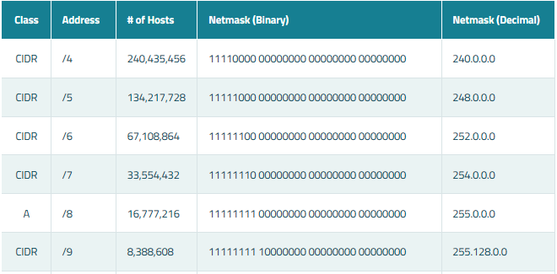

NAT

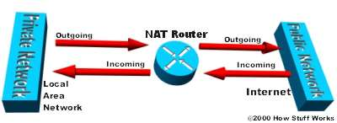

Network Address Translation (NAT) is the process where a network device, usually a firewall, assigns a public address to a computer (or group of computers) inside a private network. The main use of NAT is to limit the number of public IP addresses an organization or company must use, for both economy and security purposes.
NAT is a very important aspect of firewall security. It conserves the number of public addresses used within an organization, and it allows for stricter control of access to resources on both sides of the firewall.

3. Cryptography

I researched about various ciphers, such as morse code, true codes, vigenere code, monoalphabetic substitution and playfair code. Morse code is a method of transmitting text information as a series of on-off tones, lights, or clicks that can be directly understood by a skilled listener or observer without special equipment. It is named for Samuel F. B. Morse, an inventor of the telegraph. Actually, Morse code is not a code but a cipher.
Moreover, hash functions were discussed along with the examples of primitive hash functions such as SHA1 and MD5. Also, public and private cryptography was discussed. This motivated me to explore new hash functions like SHA2, SHA256 etc. SHA1 and MD5 are no longer used as there are a lot of websites that can decode SHA1 and MD5 code.
Also, I went through the basics of how cross site scripting works.


4. Network Layers and Packet Sniffers

OSI model was discussed along with how each packet sent over a network can be captured and analysed by packet sniffers like Wireshark. I enjoyed the Wireshark tutorial and got to learn new stuff like finding attacks happening over a network. I learnt about the slow loris attack (which works only on Apache servers)and the man-in-the-middle attack. The majority of servers used in the world today are Apache servers so this is a dangerous type of attack. Slowloris is a type of denial of service attack tool invented by Robert "RSnake" Hansen which allows a single machine to take down another machine's web server with minimal bandwidth and side effects on unrelated services and ports. It was released on 17th June 2009.
Slowloris tries to keep many connections to the target web server open and hold them open as long as possible. It accomplishes this by opening connections to the target web server and sending a partial request. Periodically, it will send subsequent HTTP headers, adding to—but never completing—the request. Affected servers will keep these connections open, filling their maximum concurrent connection pool, eventually denying additional connection attempts from clients.
In cryptography and computer security, a man-in-the-middle attack (MITM) is an attack where the attacker secretly relays and possibly alters the communication between two parties who believe they are directly communicating with each other. One example of man-in-the-middle attacks is active eavesdropping, in which the attacker makes independent connections with the victims and relays messages between them to make them believe they are talking directly to each other over a private connection, when in fact the entire conversation is controlled by the attacker. The attacker must be able to intercept all relevant messages passing between the two victims and inject new ones.
An example of man-in-the-middle attack :
Alice sends a message to Bob, which is intercepted by Mallory:
Alice "Hi Bob, it's Alice. Give me your key." → Mallory ->Bob
- Mallory relays this message to Bob; Bob cannot tell it is not really from Alice:
Alice-> Mallory "Hi Bob, it's Alice. Give me your key." →Bob
- Bob responds with his encryption key:
Alice ->Mallory ← [Bob's key] Bob
- Mallory replaces Bob's key with her own, and relays this to Alice, claiming that it is Bob's key:
Alice ← [Mallory's key] Mallory ->Bob
- Alice encrypts a message with what she believes to be Bob's key, thinking that only Bob can read it:
Alice "Meet me at the bus stop!" [encrypted with Mallory's key] →Mallory ->Bob
- However, because it was actually encrypted with Mallory's key, Mallory can decrypt it, read it, modify it (if desired), re-encrypt with Bob's key, and forward it to Bob:
Alice ->Mallory "Meet me at the van down by the river!" [encrypted with Bob's key] → Bob
- Bob thinks that this message is a secure communication from Alice.
- Bob goes to the van down by the river and gets robbed by Mallory.
- Alice does not know that Bob was robbed by Mallory thinking Bob is late.
- Not seeing Bob for a while, she determines something happened to Bob.
This example shows the need for Alice and Bob to have some way to ensure that they are truly each using each other's public keys, rather than the public key of an attacker. Otherwise, such attacks are generally possible, in principle, against any message sent using public-key technology. To avoid man-in-the-middle attacks, we use signed certificates. In CA signed certificates, a third party which is the certificate authority signs the data
In cryptography, a certificate authority or certification authority (CA) is an entity that issues digital certificates. A digital certificate certifies the ownership of a public key by the named subject of the certificate. This allows others (relying parties) to rely upon signatures or on assertions made about the private key that corresponds to the certified public key. A CA acts as a trusted third party—trusted both by the subject (owner) of the certificate and by the party relying upon the certificate. The format of these certificates is specified by the X.509 standard. However, if the attacker gets the cetificate authority to fraudulently sign certificates, then every piece of communication going through the CA would be intercepted.
There are other types of attacks such as ARP spoofing/poisoning, denial of service (DoS) attacks, distributed denial of service attacks and amplified denial of service attacks.

I further learnt about different tiers of ISPs and internet protocols like HTTP,SMTP,POP3.

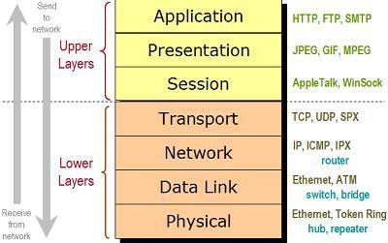

5. Assembly Language

A brief introduction to assembly language was given.
I learnt briefly about using the Netwide Assembler (NASM). The Netwide Assembler (NASM) is an assembler and disassembler for the Intel x86 architecture. It can be used to write 16-bit, 32-bit (IA-32) and 64-bit (x86-64) programs. NASM is considered to be one of the most popular assemblers for Linux. It helped me understand what was going under the hood while writing C programs. Also, radare was extremely helpful as it converted C code into assembly code which gave me an in depth insight into C language.
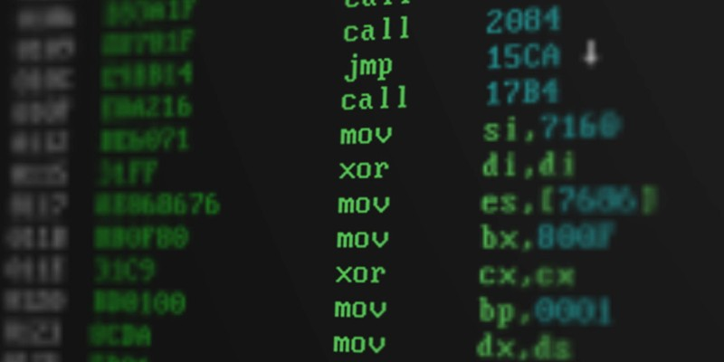

My feedback about the sessions :

IEEE Summer Project has been very beneficial for me to explore new domains of networking and security. I appreciated the regular sessions that were held for everyone to express their views and doubts, helping us understand the topic to a great extent. The topics were explained at normal pace and the mentors were open to all doubts.
- But I feel that this summer project would have been better if we are able to work on simulations of routers and code them so as to configure them in a network.
- Also, I feel that an introduction to using network security OSes like Kali Linux would have been better.
With that aside, I totally enjoyed the summer project and I appreciate the effort that the mentors have taken to make the topics easier to learn.

